**Java Architecture**

* Process of compilation and interpretation
* [Java](https://www.edureka.co/blog/java-tutorial/) code is converted into byte code which is done by the Java Compiler.
* The byte codes are converted into machine code by the JVM.
* The Machine code is executed directly by the machine.

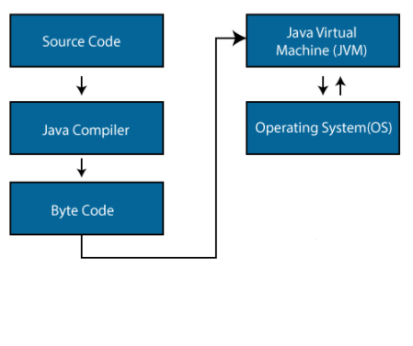

**Components of Java Architecture**

There are three main components of Java language:

1. JVM (Java Virtual Machine)
2. JRE (Java Runtime Environment)
3. JDK (Java Development Kit)

### ****Java Virtual Machine:****

Java applications are called WORA (Write once Run Anywhere) because of their ability to run a code on any platform. This is done only because of JVM. The JVM is a Java platform component that provides an environment for executing Java programs. JVM interprets the byte code into machine code which is executed in the machine in which the Java program runs.

* Loads the code
* Verifies the code
* Executes the code
* Provides runtime environment

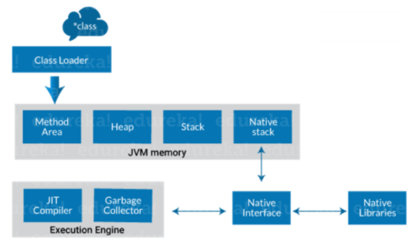

**Class Loader**: Class loader is a subsystem of JVM. It is used to load class files. Whenever we run the java program, class loader loads it first.

**Class method area**: It is one of the Data Area in JVM. Static Variables, Static Blocks, Static Methods, Instance Methods are stored in this area.

**Heap**: A heap is created when the JVM starts up. It may increase or decrease in size while the application runs.

**Stack**: JVM stack is known as a thread stack. It is a data area in the JVM memory which is created for a single execution thread.

**Native stack**: It contains all the native methods used in application.

**Execution Engine:**

* JIT compiler
* Garbage collector

**JIT compiler:** The [Just-In-Time (JIT) compiler](https://www.edureka.co/blog/just-in-time-compiler/) is a part of the runtime environment. It helps in improving the performance of Java applications by compiling byte codes to machine code at run time.

**Garbage collector:** As the name explains that [Garbage Collector](https://www.edureka.co/blog/garbage-collection-in-java/) means to collect the unused material. Garbage collector works in two simple steps known as Mark and Sweep:

* Mark – it is where the garbage collector identifies which piece of memory is in use and which are not
* Sweep – it removes objects identified during the “mark” phase.

### ****Java Runtime Environment:****

The JRE software builds a runtime environment in which Java programs can be executed. The JRE is the on-disk system that takes your Java code, combines it with the needed libraries, and starts the JVM to execute it. The JRE contains libraries and software needed by your Java programs to run. JRE is a part of JDK but can be downloaded separately.

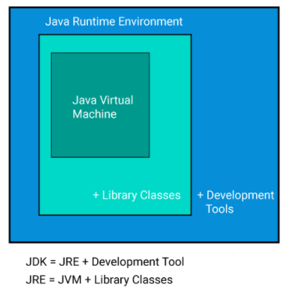

### ****Java Development Kit:****

The Java Development Kit (JDK) is a software development environment used to develop Java applications and applets. It contains JRE and several development tools, an interpreter/loader (java), a compiler (javac), an archiver (jar), a documentation generator (javadoc) accompanied with another tool.

**java** : launcher for all the java applications.  
**javac** : complier of the java programming languages.  
**javadoc**: API documentation generator.  
**jar**: creates and manage all the JAR files.